Automatic Fruit Freshness Recognition System

**Usman Safdar**

**Aimen Farooq**

DEPARTMENT OF COMPUTER SCIENCES

COMSATS UNIVERSITY ISLAMABAD,

ATTOCK CAMPUS – PAKISTAN

SESSION 2017-2021

Automatic Fruit Freshness Recognition System

*Undertaken By:*

**Usman Safdar**

CUI/FA17-BCS-106/ATK

**Aimen Farooq**

CUI/FA17-BCS-070/ATK

*Supervised By:*

**DR. YASIR ALI SHAH**

A DISSERTATION SUBMITTED AS A PARTIAL FULFILLMENT OF THE

REQUIREMENTS FOR THE DEGREE OF BECHELOR OF COMPUTER SCIENCE

DEPARTMENT OF COMPUTER SCIENCES

COMSATS UNIVERSITY ISLAMABAD,

ATTOCK CAMPUS – PAKISTAN

SESSION 2017-2021

***UNDERTAKEN***

We hereby declare that this software, neither whole nor as a part has been copied out from any source. It is further declared that we have developed this software and accompanied report entirely based on our personal efforts. If any part of this project is proved to be copied out from any source or found to be reproduction of some other. We will stand by the consequences. No Portion of the work presented has been submitted of any application for any other degree or qualification of this or any other university or institute of learning.

Usman Safdar Aimen Farooq

--------------------------- -------------------------

**FINAL APPROVAL**

It is to certify that the final year project of BS(CS) “Automatic Fruit Freshness Recognition System” is developed by Usman Safdar CUI/FA17-BCS-106/ATK and Aimen Farooq CUI/FA17-BCS-070/ATK under the supervision of “Dr. Yasir Ali Shah”. It is fully adequate, in scope and quality for the degree of Bachelor of Science in Software Engineering.

***Committee:***

1. External Examiner ____________________________

(Examiner Name)

Designation

University Name

2. Supervisor ____________________________

(Supervisor Name)

3. Chairperson ____________________________

(Chairperson Name)

4. Dean/Director ____________________________

(Dean/Director Name)

**DEDICATION**

We dedicate this piece of work to our parents who brought us up in an appropriate educational atmosphere, our worthy teachers who had been a source of encouragement, guidance and enlightenment at each step of our life. Our parents helped us since the beginning of our higher education to cope up with all challenge that we face.

**ACKNOWLEDGEMENT**

Praise be to Allah, the most Beneficent and the most Merciful, the lord of the world, who guides us in the darkness and help us in difficulties. Our all powers are due to His Almighty favors.

We express our deep sense of gratitude to our research supervisor, Dr. Yasir Ali Shah whose valuable guidance and supervision has made this work more colorful and educative. Without his valuable suggestions we believe this study would not have been completed. We are deeply indebted to him for his encouragement and continual help during this work.

Usman Safdar Aimen Farooq

--------------------------- -------------------------

**PROJECT BRIEF**

PROJECT NAME AUTOMATIC FRUIT FRESHNESS RECOGNITION SYSTEM

ORGANIZATION NAME COMSATS UNIVERSITY ISLAMABAD, ATTOCK CAMPUS

OBJECTIVE RECOGNITION OF FRESHNESS OF FRUITS

UNDERTAKEN BY USMAN SAFDAR

CUI/FA17-BCS-106/ATK

AIMEN FAROOQ

CUI/FA17-BCS-070/ATK

SUPERVISED BY DR. YASIR ALI SHAH

LECTURER

COMPUTER SCIENCE

CUI, ATTOCK CAMPUS

STARTED ON OCTOBER 2020

COMPLETED ON EXPECTED JUNE 2021

COMPUTER USED HP AMD RADEON R5,

10 COMPUTE CORES

2.4 GHZ PROCESSOR

8GB RAM

SOURCE LANGUAGE PYTHON 3.8

OPERATING SYSTEM Windows 10

TOOLS USED PYCHARM, PYQT5 DESIGNER,

ANACONDA, MS WORD

PYTHON 3.7 IDE

**ABSTRACT**

Agriculture has always been an important economic and social sector for people. Fruit production is particularly important with high demand from all households. The quality of fruits plays an important role in consumption and thus affects its sales. The world’s survival is based on agricultural products and their quality. All companies and organizations that manufacture, display, transport, or prepare food for sale check the quality of food.Attempts to use image pre-processing techniques to extract the colour, size, and other attributes or features of the training dataset that make up the image, then using supervised and unsupervised learning, we form the trained data from the training dataset. Further, the new image of fresh fruit whose quality is to be predicted undergoes image processing. Later we apply machine learning algorithms on the extracted attributes, referring to its outcome and predicting the trained dataset quality. Nowadays deep learning (DL)is one of the most used machine learning-based methods. Deep learning is characterized by its high level of abstraction and the ability to automatically learn modes that exist in the image. It can also learn reliable representation from images. We use a classifier algorithm which is a deep learning algorithm that is used to classify data into labelled classes or categories of information. Convolution Neural Network (CNN) is the main DL architecture used for image classification. Especially in agriculture, CNN-based approaches have been used for fruit classification and fruit detection. The use of CNN for fruit recognition has increased significantly due to increased achievement of excellent results, both using new models and previously trained networks for transfer learning. We have got an overall 94% accuracy of the dataset. The six types of classes Rotten Apples, Fresh Apples, Rotten Oranges, Fresh Apples, Rotten Bananas, and Fresh Bananas were used for prediction. We achieved the highest 96.99 % accuracy for the fresh oranges, 94.87 for rotten oranges, 95.43% for rotten apples, 95.18% for fresh apples, 95.27% for fresh bananas, and 89.69% for rotten bananas.

**Table of Contents**

**Table of Contents**

**Chapter 1 4**

**INTRODUCTION 4**

1.1 Project Background 4

1.2 Brief 4

1.3 Relevance to Course Modules 4

1.3.1 Machine Learning 4

1.3.2 Human Computer Interaction 4

1.4 Literature Review 4

1.4.1 Fruit Recognition System 4

1.4.2 Fruit Detection using Deep Learning 4

1.4.3 Deep Fruit Detection in Orchards 4

1.5 Methodology and Software Lifecycle for This Project 4

1.5.1 Methodology 4

1.5.2 Rational behind choosing this strategy 4

**Chapter 2 4**

**PROBLEM DEFINITION 4**

2.1 Problem Definition 4

2.2 Problem Statement 4

2.3 Deliverables 4

2.3.1 DESKTOP BASED APPLICATION INTERFACE 4

2.3.2 IMAGE UPLOADING 4

2.3.3 IMAGE PRE-PROCESSING 4

2.3.4 CLASSIFIER 4

2.4 Development Requirements 4

2.5 Current System 4

2.5.1 Image Pre-processing 4

**Chapter 3 4**

**REQUIREMENT ANALYSIS 4**

3.1 Requirement Analysis 4

3.2 Use Case Diagram 4

3.3 Detailed Use Case 4

3.4 Functional Requirements 4

3.4.1 Image Uploading 4

3.4.2 Pre-processing 4

3.4.5 Classifier CNN 4

3.4.6 CNN Training 4

3.4.9 Fruit Label 4

3.4.10 Close Application 4

3.5 Non-Functional Requirements 4

3.5.1 Efficiency 4

3.5.2 Performance 4

3.5.3 Flexibility 4

3.5.4 Usability 4

3.5.5 Availability 4

3.5.6 Reliability 4

**Chapter 4 4**

**DESIGN AND ARCHITECTURE 4**

4.1 Design and Architecture 4

4.2 System Architecture 4

4.3 Process Flow Representation 4

4.4 Design Models [along with descriptions] 4

4.4.1 Sequence Diagram 4

4.4.2 Activity Diagram 4

**Chapter 5 4**

**IMPLEMENTATION 4**

5.1 Implementation 4

5.2 Algorithm 4

5.2.1 Dataset 4

5.2.2 Preprocessing 4

5.2.3 Classification 4

5.3 User Interface 4

5.3.1 Splash Screen 4

5.3.2 Main Window 4

5.3.3 Preprocessing 4

5.3.4 Classification 4

5.3.5 Tutorial 4

**Chapter 6 4**

**TESTING AND EVALUATION 4**

6.1 Testing and Evaluation 4

6.2 Manual Testing 4

6.2.1 System Testing 4

6.2.2 Unit Testing 4

6.2.3 Functional Testing 4

6.2.4 Integration Testing 4

6.3 Tools 4

**Chapter 7 4**

**CONCLUSION AND FUTURE WORK 4**

7.1 Conclusion 4

7.2 Future Work 4

**Chapter 8 4**

**REFERENCES 4**

References 4

**List of Figures**

**Figure 1.1 Rotten Apples Image** 4

**Figure 1.2 Iterative Model** 4

**Figure 3.1 Use Case Diagram** 4

**Figure 3.2 Upload Image** 4

**Figure 3.3 Preprocessing** 4

**Figure 3.4 CNN Classification** 4

**Figure 3.5 CNN Training** 4

**Figure 3.6 (.PTH) generation** 4

**Figure 3.7 Fruit Label** 4

**Figure 4.1 System Architecture Diagram** 4

**Figure 4.2 DFD Level 0** 4

**Figure 4.3 DFD Level 1** 4

**Figure 4.4 Class Diagram** 4

**Figure 4.4 Sequence Diagram** 4

**Figure 4.5 Activity Diagram** 4

**Figure 5.1 Dataset** 4

**Figure 5.2 Split Dataset** 4

**Figure 5.3 Accuracy Graph** 4

**Figure 5.4 Loss Graph** 4

**Figure 5.5 Epochs** 4

**Figure 5.6 Splash Screen** 4

**Figure 5.7 Main Window** 4

**Figure 5.8 Select image from Folder** 4

**Figure 5.9 Upload Image** 4

**Figure 5.10 No Image** 4

**Figure 5.11 Preprocessing** 4

**Figure 5.12 Resizing** 4

**Figure 5.13 Contrast Enhancement** 4

**Figure 5.14 Noise Removal** 4

**Figure 5.15 Classification** 4

**Figure 5.16 Result** 4

**Figure 5.17 Home Screen Tutorial** 4

**Figure 5.18 Pre-processing Tutorial** 4

**Figure 5.19 Classifier Tutorial** 4

**List of Tables**

**Table 5.1 Dataset Description** 4

**Table 5.2 Classification Accuracies** 4

**Table 6.1 Upload Image** 4

**Table 6.2 Without Uploading image** 4

**Table 6.3 Preprocessing** 4

**Table 6.4 Classification** 4

**Table 6.5 Integration Testing** 4

**Table 6.6 Tools** 4

**LIST OF ABBREVIATIONS**

|  |  |
| --- | --- |
| **CNN** | Convolutional Neural Network |
| **ACC** | Artificial Neural Network |
| **DL** | Deep Learning |
| **DFD** | Data Flow Diagram |
| **FR** | Functional Requirement |

# 

# Chapter 1

# INTRODUCTION

## 1.1 Project Background

The largest economic sector of Pakistan is agriculture. It plays an important role in economic growth, not in Pakistan but in many agriculture-dependent countries. It is estimated that nearly a third of fruit costs go to decaying matters. The traditional method of examination of fruits is still done by humans through which many of the unripe fruits are ignored directly. Thus, the sales of fruits are affected as the spoiled fruits are harmful to health. The importance of fruits in people's lives and for the economic sector fruit freshness recognition is significant, but traditional method of examination is still carried out by humans. Nevertheless, this manual method is time-consuming and without the care of fruit health. So, the only suitable solution for this is the Automated Computerized Approaches using some trained model for the detection of rotten and unrotten fruit.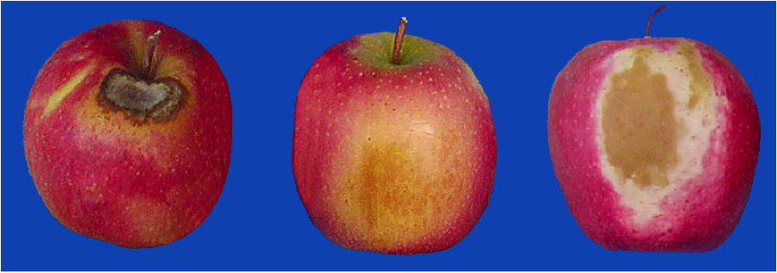

**Figure 1.1 Rotten Apples Image**

## 1.2 Brief

In the research, we are analyzing a method of detecting the freshness of fruits based on the maturity, shape and color by using automated computerized approaches, as the fruit color and shape provide visual property. The technique might prove efficient to hold the fruit in an unharmed shape as the unmatured manual human method ignores the shape of fruits in most cases. Considering the importance of fruits in people's lives and the economic sector, the manual method of recognition can be replaced by the Automated detection system, in which we have to train a model based on specific qualities (maturity, color, and shape) of fruits using different programming languages codes. That will result in more accuracy and less time than the manual process.

In recent years it has been discovered that deep learning techniques are gradually used for detection. Similarly, we will also use deep learning techniques for the recognition of fruit's freshness. The features like the shape and color of the fruits are very critical. Here we get the shape of the fruit from a digital image while color recognition involves multiple physiological concepts. Now it becomes a difficult process to recognize the colors of the fruits in the digital image, for many different color systems are used for sorting fruit's freshness from one another based on their color.

In the research, we are designing a complete structure based on neural network techniques to recognize the size, color, shape, and maturity of the fruit. We have come across that while recognizing fruit freshness the main factor that matters is its color from the other fruits, but having multiple fruits having the same color makes the recognition difficult for the trained model. So along with color, we are considering the size and shape also to solve this problem, as classification of fruits based on size, shape, and color involves extraction through the physical observation of the fruit through which required information about a particular fruit can be obtained.

Currently, we are using Deep Learning (DL) commonly used Machine Learning (ML) method in our recognition system. Deep Learning Techniques are characterized by their high level of abstraction and the ability to automatically learn and recognize different modes of images once they have been trained. Further in DL, we will use most common method known as the Convolutional Neural Network (CNN) method for the recognition of the fruit’s freshness process. CNN is an Artificial Neural Network (ACC) system that is used to perform convolutional operations, basically used for image recognition, image classifications, object detections, etc.

## 1.3 Relevance to Course Modules

### **1.3.1 Machine Learning**

In Machine learning we had studied about different algorithms which are used to train models to perform task automatically after getting the training data.

### **1.3.2 Human Computer Interaction**

A system which is interactive is easy and comfortable for the user to use the system and understand it easily and so the course helps us to design an interactive system.

## 1.4 Literature Review

This portion contains the complete related past work and reports that have been completed.

### 1.4.1 Fruit Recognition System

Y. Song put forward a method which helps us to count fruits from images in cluttered greenhouses. He developed an application which helps us locate and then count green as well as red pepper fruits that grew in a large and dense environment of pepper plants. Approach here is based on a looking for points of interest.

### 1.4.2 Fruit Detection using Deep Learning

When we talk about looking for fruits in an image, Inkyu Sa, devised a new method for such purpose. Inkyu Sa adapted a Faster Region-based convolutional network. In this method autonomous robots used a neural network capable of harvesting fruits. Underlying neural network was trained using RGB and NIR images. Output of this neural network is a multi-modal network. Output of this neural network is much better than already existing networks.

### 1.4.3 Deep Fruit Detection in Orchards

When we talk about recognizing fruits that are grown in an orchard, Bargoti S. proposed autonomous robots that are used for harvesting. This was a difficult task because in order to obtain better results images that span many fruit trees were required and number of fruits in such images may be large e.g., an almond tree may contain 1500+ fruits per image. Furthermore, since images of fruits are always taken outside, therefore, they may contain variance in size, color, etc.

## 1.5 Methodology and Software Lifecycle for This Project

Project methodology is an important phase of any project because it is a key element for the overall results of the project. For this it is important to understand the concepts and the steps to achieve the goals of our project.

### 1.5.1 Methodology

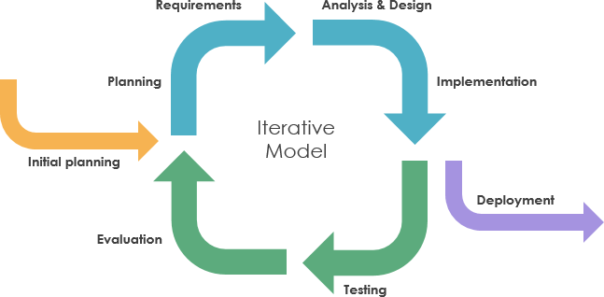

**Figure 1.2 Iterative Model**

## In this project, we will be using Iterative Model because software requirements are in such a way that they can be developed incrementally and delivered. At any point, a plan may be constructed for the next increment. Plan is not for any long-term phase. This helps us to easily modify the product as per our needs.

### 1.5.2 Rational behind choosing this strategy

* We select this methodology because our requirements are clear so through this the development will be fast and easy to test and debug as compared to developing the whole software.
* In this methodology we will develop application through repetitive increments that in first increment we will develop interface while in second increment we will add functionalities that a system will perform.

# Chapter 2

# PROBLEM DEFINITION

## 2.1 Problem Definition

The aim of our project is to recognize the fruit's freshness. This system will detect whether the fruit is rotten or unrotten, based on the shape, physical appearance, size, and color of the fruits.

## 2.2 Problem Statement

As technology evolution is getting fast day by day as people are getting more dependent on technology. Technologies are moving toward automated systems. As most of the economic sector and people all over the world rely on fruits as the quality of the fruits is necessary, but to analyze the fruits still old traditional methods are used by the farmers or customers that consume more time and effort. So, in this research, our main aim is to identify the problems related to the automated fruit freshness system. This will help farmers, later on, the wholesaler dealers, and in the end, the customers to check the fruit freshness based on its maturity, color, size, and shape. There is a need to expand the different types of visual characteristics such as color, texture, size, and shape to distinguish between a rotten and unrotten fruit.

## 2.3 Deliverables

### 2.3.1 DESKTOP BASED APPLICATION INTERFACE

A Desktop application will allow the user to evaluate the application in the perspective of easiness and how the application look alike.

### 2.3.2 IMAGE UPLOADING

Variety of images of fruits required for the detection of their Freshness.

### 2.3.3 IMAGE PRE-PROCESSING

The images are pre-processed for the accurate and efficient results.

### 2.3.4 CLASSIFIER

The image is classified completely to recognize fruits freshness and classify the fruits.

## 2.4 Development Requirements

Following are the requirements which the user of the system must fulfill in order to run the system on their laptops or PCs.

**OS Requirement**

WINDOWS OS

**Software Requirements**

Interface: PyQt Designer IDE: PyCharm,

Dataset based work,

Programming,

Anaconda

Language: Python

**Other Requirements**

For presentation, we will use MS Word and MS Power Point

## 2.5 Current System

Following are the current systems of our project.

### 2.5.1 Image Pre-processing

The system can

* Upload and remove an image
* Pre-Process the image
* Resize the image
* Contrast Enhancement
* Remove Noise
* Clear the results if required

**2.5.2 Image Classification**

The system goes through

* Classify the original image or the pre-processed image
* Predicts the rotten or fresh fruit on the basis of trained model.

# Chapter 3

# REQUIREMENT ANALYSIS

## 3.1 Requirement Analysis

Software Requirement Specification (SRS) provides the basic understanding of functional as well as non -functional requirements. We can consider it as a starting point of project because it serves a written contract between client and organization about the features and functionalities of the project. With the help of SRS both client and organization make clear to each other about the deliverable project.

## 3.2 Use Case Diagram

The use case diagram for our system is given below. The user will input fruit image from system directory to application. After giving an input to a system, system must start pre-processing process. The pre-processed image will be passed for classification. Classifier extracting features and then classify fruit freshness into different types. Result is displayed after correct classification of fruit freshness classes along with their labels and accuracies.

**Figure 3.1 Use Case Diagram**

## 3.3 Detailed Use Case

**1-Use case 1:** Input Fruit Image.

**Actors:** User

**Description:** User will input image from system directory to application as initial step to use this application.

**Pre-condition:** User has provided a fruit image to a system as an input and it must be .jpg format.

**Post-condition:** After giving an input to a system, then system will go through pre-processing if required or can be used directly.

**2-Use case 2:** Pre-processing

**Actors:** System.

**Description:** User will input image for pre-processing.

**Pre-condition:** User has uploaded an image.

**Post-condition:** Image will go for classification

**3-Use case 3:** Classification

**Actors:** System

**Description:** The original or pre-processed image will be classified.

**Pre-condition:** User must provide an image or pre-processed image to a system; it must be in .jpg format.

**Post-condition:** System predicts rotten or fresh fruits.

**4-Use case 4:** Predict Fresh or Rotten Fruit

**Actors:** System

**Description:** After classification of each of the features the fruits are matched with the trained model for accuracy and generating the results.

**Pre-condition:** Image classification has been done

**Post-condition:** Respond back to user

**5. Use-case 5**: Close Application

**Actors**: System

**Description**: After Output is displayed, the application can be closed

**Pre-condition:** Output is displayed to user

**Post-condition**: Application will be closed

## 3.4 Functional Requirements

Functional requirements involve processes, methods, and functionalities that a system is supposed to perform. Following are the functional requirements of our system:

* A reliable system for fruit freshness taking minimum response time.
* The system will take image from user.
* User can directly perform classification or proceed through pre-processed image if required.
* Pre-processed or original image will be compared with the trained model and the fruit freshness will be predicted.
* Output will display the fruit type and its class.

### 3.4.1 Image Uploading

The user will upload an image to system first to proceed.

**Figure 3.2 Upload Image**

### 3.4.2 Pre-processing

Pre-processing is the first important part of our system framework. This process is used to refine irrelevant data, missing values, and noise from data. We use it in our system for image resizing, noise removal and contrast enhancement.

**Figure 3.3 Preprocessing**

### 3.4.5 Classifier CNN

In neural networks, Convolutional Neural Network (CNNs) is one of the main categories to do images recognition, images classifications. Object’s detections, recognition faces etc., are some of the areas where CNNs are widely used. The system performs the classification and predict the fruit freshness.

**Figure 3.4 CNN Classification**

### 3.4.6 CNN Training

We have used CNN for training our fresh and rotten fruit dataset of images. The trained model generates a PyTorch(.PTH) file, that helps predicts the fresh and rotten fruit. The model is trained in 10 epochs.

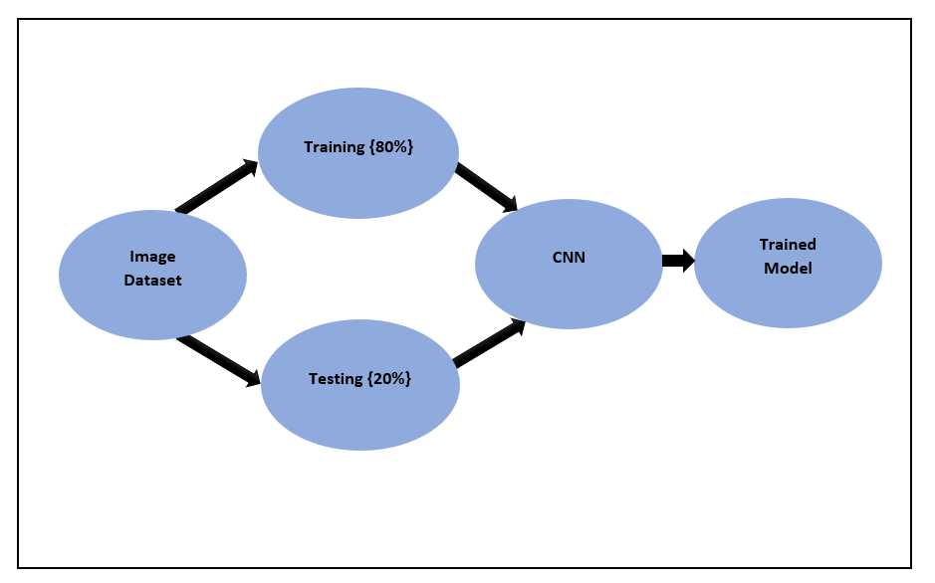

**Figure 3.5 CNN Training**

**3.4.7 PyTorch (.PTH) File Generating**

The trained model generates a PyTorch(.PTH) file, that helps predicts the fresh and rotten fruit.

**Figure 3.6 (.PTH) generation**

**3.4.8 Testing Model**

After the model is trained now it is ready to be used in application to predict the rotten or fresh fruits.

### 3.4.9 Fruit Label

The fruit label is displayed.

**Figure 3.7 Fruit Label**

### 3.4.10 Close Application

In the end results will be generated based on the classification of the fruit, proving the fruit to be rotten or fresh. To exit the application user can click the closing button.

## 3.5 Non-Functional Requirements

Non-Functional requirements are those requirements that specify the quality of the system. Non-functional requirements of our system are:

### 3.5.1 Efficiency

This system is efficient as it does not require any kind of effort to use it and user friendly.

### 3.5.2 Performance

Performance of our system is efficient taking less time to perform actions.

### 3.5.3 Flexibility

The system provides the user to load the image easily, preform pre-processing, perform classification and easily changeable.

### 3.5.4 Usability

This system is user friendly so that user will not face any difficulty while using the system.

### 3.5.5 Availability

Our system will be available in the Food Markets.

### 3.5.6 Reliability

Our system will recover itself in less time in case of any failure. Our system will be reliable enough to use.

# Chapter 4

# DESIGN AND ARCHITECTURE

## 4.1 Design and Architecture

After gathering all requirements, the next step is to start planning how we are going to develop our project, how much resources, costs, time, benefits, and other items are required. Onwards we move to the designing and architecture phase that which techniques and methods we can use and how we are going to develop our project. This phase really matters while starting the development.

## 4.2 System Architecture

**Figure 4.1 System Architecture Diagram**

## 4.3 Process Flow Representation

A data flow diagram is graphical interpretation of information move from a data framework is called data flow diagram. A DFD is used for basic step to create an overview of the system without going into great aspect, which can later be elaborated.

**Figure 4.2 DFD Level 0**

**Figure 4.3 DFD Level 1**

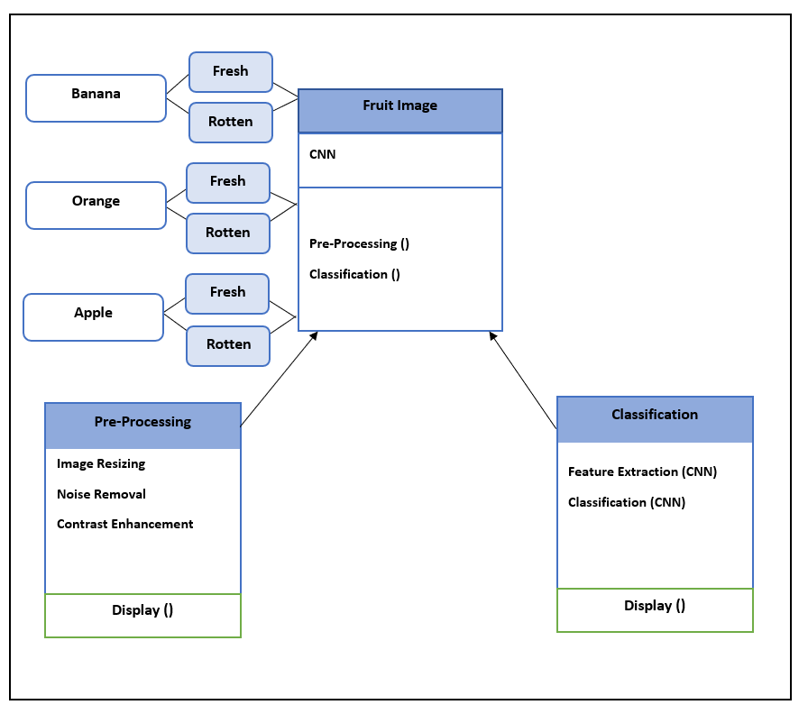

**Figure 4.4 Class Diagram**

## 4.4 Design Models [along with descriptions]

Following are the design models of our system.

### 4.4.1 Sequence Diagram

The figure given below is the sequence diagram of our system. The user will first upload an image that will go through the pre-processing (if required) and then through classification recognizing the freshness of the fruits, along this user can get results of a single actions at a time.

**Figure 4.4 Sequence Diagram**

### 4.4.2 Activity Diagram

**Figure 4.5 Activity Diagram**

# Chapter 5

# IMPLEMENTATION

## 5.1 Implementation

All the Algorithms and user interfaces used to develop the project are discussed in this chapter. Implementation is the most prominent phase of development. At this stage, all the ideas are transforming into a meaningful picture. This step is a significant and challenging step towards development skills. An application is the result of the successful implementation of a project, various testing approaches, algorithms, and results.

## 5.2 Algorithm

There are five Algorithms implemented in this project. A detailed overview and the various

outcomes are shown below.

### 5.2.1 Dataset

The dataset used in this project is taken from Kaggle. All the images used are RGB images and are in (.JPG) format. It contains 3 types of fruits each having 2 classes as unrotten and rotten fruit. All images are placed in separate folders corresponding to the fruit type.

* **Fresh Apples**
* **Rotten Apples**
* **Fresh Oranges**
* **Rotten Oranges**
* **Fresh Banana**
* **Rotten Banana**

**Figure 5.1 Dataset**

**Table 5.1 Dataset Description**

|  |  |  |
| --- | --- | --- |
| Fruit Types | Classes | Images |
| Apples | Fresh Apples | 1500+ |
|  | Rotten Apples | 1500+ |
| Oranges | Fresh Oranges | 1500+ |
|  | Rotten Oranges | 1500+ |
| Banana | Fresh Banana | 1500+ |
|  | Rotten Banana | 1500+ |

### 5.2.2 Preprocessing

Pre-processing is the basic step to refine data from noise, garbage, or irrelevant data. Preprocessing is the first and important part of the framework. Preprocessing methods will be diverse for various applications based on the ideal dataset of a visual. For removing noise, dataset images are passed through various operations of pre-processing.

Following techniques are applied to remove noise from images.

#### 5.2.2.1 Image Resizing

After taking the image as input there is a need to resize an image. It is important to give a standard size to all input test images so that they all contain the same features. Images provided in the dataset are (250,250)and we resized them into(64,64)because machine learning models learn faster on smaller images. All images are rescaled to(64,64)and model is trained over them.

#### 5..2.2.2 Image Enhancement

The main aim of doing contrast enhancement is that the image is more clear and sharper than before. Contrast Enhancement changes the brightness and contrast of pixels of an image. This step is done by adjusting the pixel intensities of an image.

#### 5.2.2.3 Image Noise Removal

If an image contains any noise, then it is important to restore from noise to make the classification process efficient. For this purpose, we use a median filter which is highly effective in removing noise from the image. The median is calculated by first sorting all pixel values into ascending order and then replacing the pixel with the middle pixel value.

### 5.2.3 Classification

Many classifiers are proposed in the literature to classify Fruit freshness into different types namely, Artificial Neural Network (ANN), Support Vector Machine (SVM), K-Nearest Neighbour (KNN), Discriminant Analysis, etc.

We use Convolutional Neural Network (CNN) classifier to classify Fruit into two types (Fresh and Rotten). Our model is trained on the dataset. Based on features, the classifier compares the input test image with trained data and displays the result.

#### 5.2.3.1 CNN Architecture

In this architecture there are convolutional layer, Max Pooling layer, Rectified Linear Unit (ReLU activation function) and fully connected layers.

##### 5.2.3.1.1 Convolutional Layer

Each input image is placed into series of convolutional layers with filters. There are **2** convolutional layers used in the first convolutional layer we use 3 channels image with 32 channel output and with 3*3 kernel size, the second convolutional layer uses 32 channel input with 64 channel output along with 3*3 kernel.

##### 5.2.3.1.2 Max Pooling

Max Pooling layer is used for down sampling the image. Down sampling reduce dimension and preserve the feature of Fruit images. We use **2** Max Pooling layers.

##### 5.2.3.1.3 Fully Connected

Two fully connected layers are used in this project.

#### 5.2.3.2 Implementation Steps

1. **Dataset**

**Figure 5.2 Split Dataset**

1. **CNN Model**

CNN network uses an image when an image and filters combined that produce features. Classification of fruit labels is done by using convolutional layer, Max pooling, ReLU activation function, and fully connected layers are used.

1. **Training**

In training phase, we have used 6000 images. Our CNN model trained over 80% of images in the train folder.

1. **Testing**

In the testing phase, we used 250 images of each class of fruit labels. The testing phase is done when an image is browsed from the testing folder and that image is matched with the pre-trained model and predicts the class of fruit label.

1. **Output**

The accuracies of each class of fruit labels are shown individually.

1. **Accuracies**

**Table 5.2 Classification Accuracies**

|  |  |  |  |
| --- | --- | --- | --- |
| Labels | Fruit Class | Accuracy | Overall Accuracy  **94%** |
| 1 | Fresh Apples | 94.18% |
| 2 | Rotten Apples | 95.43% |
| 3 | Fresh Oranges | 96.99% |
| 4 | Rotten Oranges | 94.87% |
| 5 | Fresh Bananas | 95.27% |
| 6 | Rotten Bananas | 89.69% |

#### 5.2.3.3 Graphical Representation

##### 5.2.3.3.1 Accuracy Graph

**Figure 5.3 Accuracy Graph**

##### 5.2.3.3.2 Loss Graph

**Figure 5.4 Loss Graph**

##### 5.2.3.3.3 Epochs

**Figure 5.5 Epochs**

## 5.3 User Interface

A user-friendly and simple interface is one of the most demanding things in the world of technologies nowadays. The simple and interactive interface of the application is important because the user did not face any problems while using the application. The interface of our application is designed in PyQt designer in python. PyQt installer comes with a PyQt designer (GUI Tool). PyQt designer is simply a drag and drop sort of interface that provides the facility of designing an attractive interface.

Working of each module and interface are shown below step by step:

### 5.3.1 Splash Screen

**Figure 5.6 Splash Screen**

### 5.3.2 Main Window

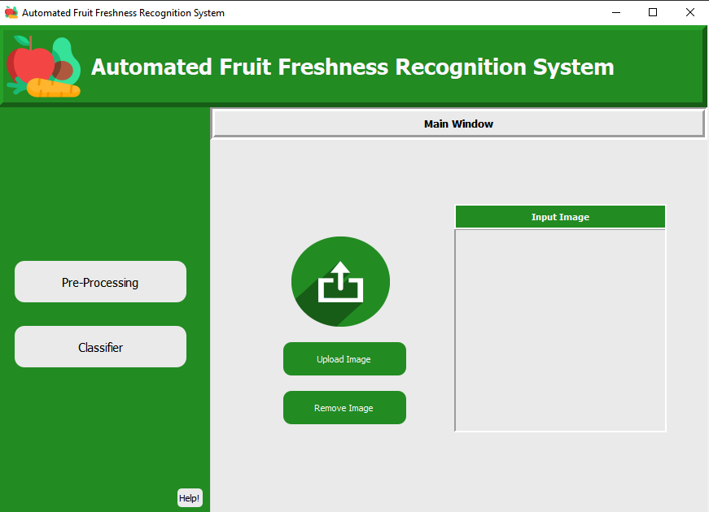

**Figure 5.7 Main Window**

**Figure 5.8 Select image from Folder**

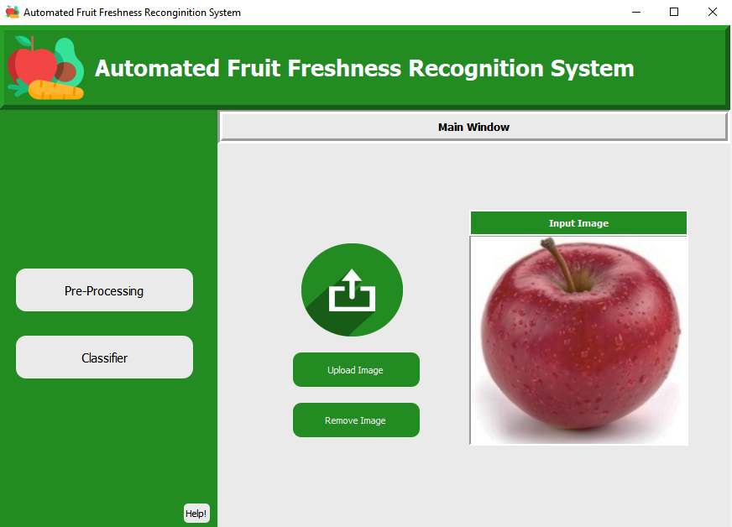

**Figure 5.9 Upload Image**

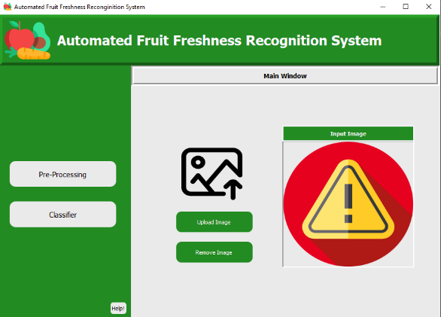

**Figure 5.10 No Image**

### 5.3.3 Preprocessing

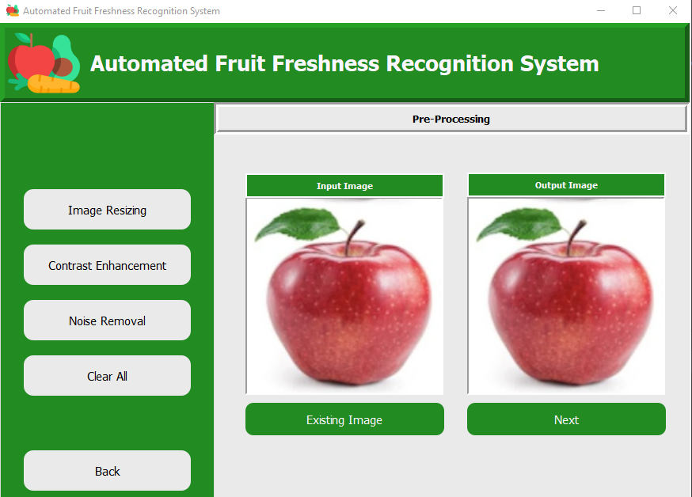

**Figure 5.11 Preprocessing**



**Figure 5.12 Resizing**

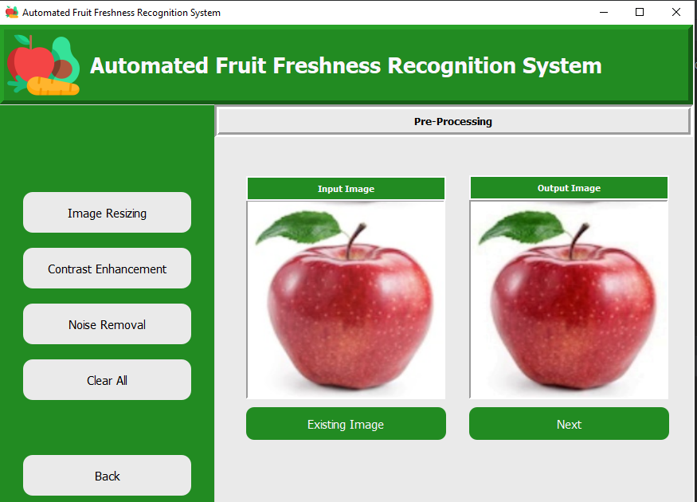

**Figure 5.13 Contrast Enhancement**



**Figure 5.14 Noise Removal**

### 5.3.4 Classification

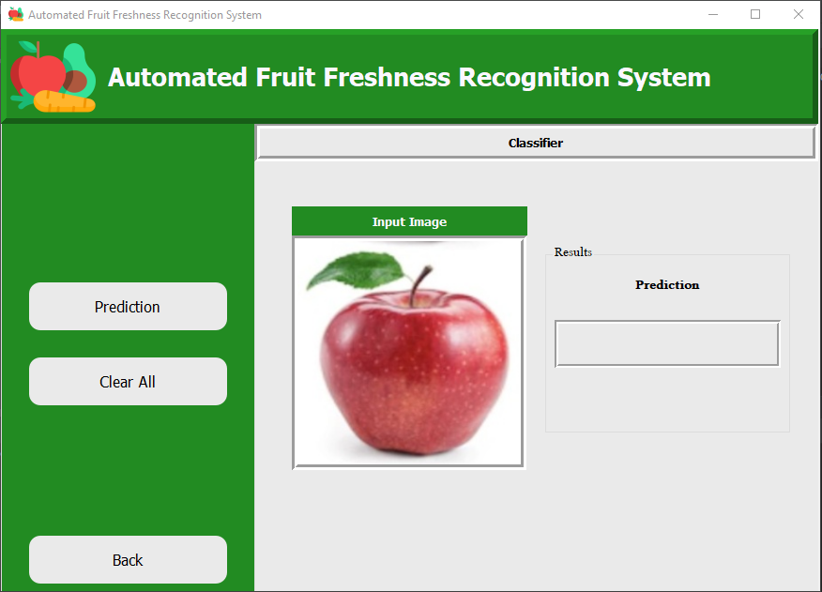

**Figure 5.15 Classification**

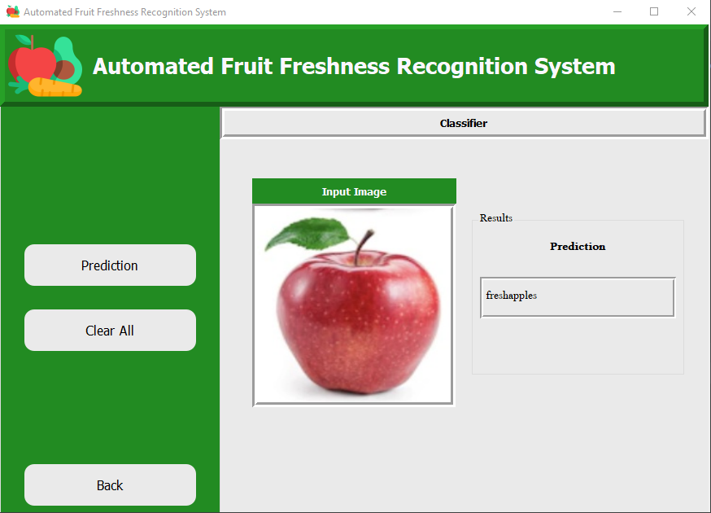

**Figure 5.16 Result**

### 5.3.5 Tutorial

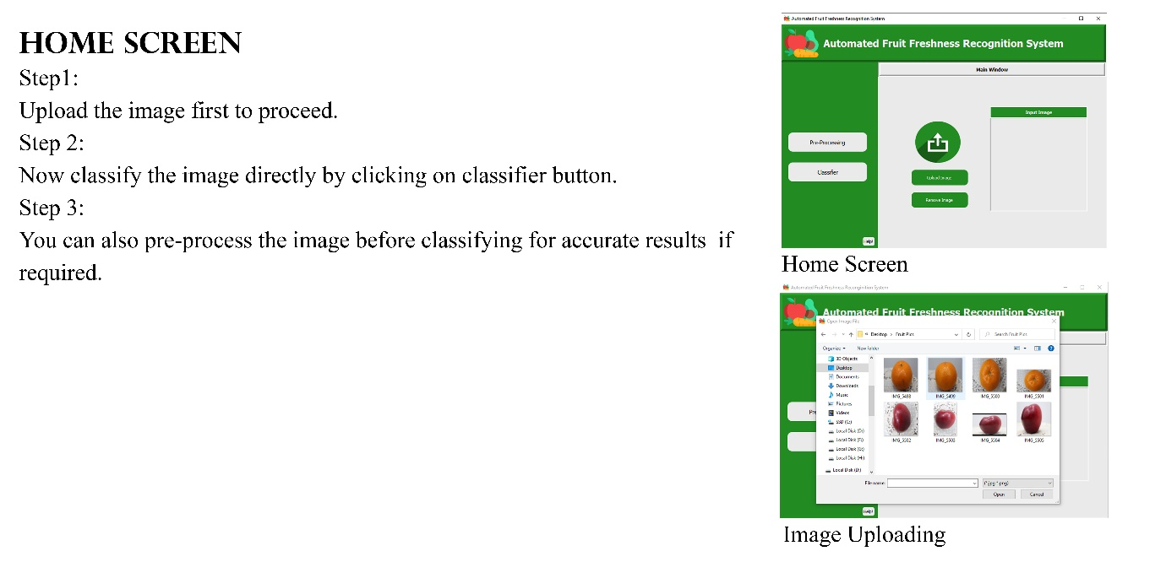

**Figure 5.17 Home Screen Tutorial**

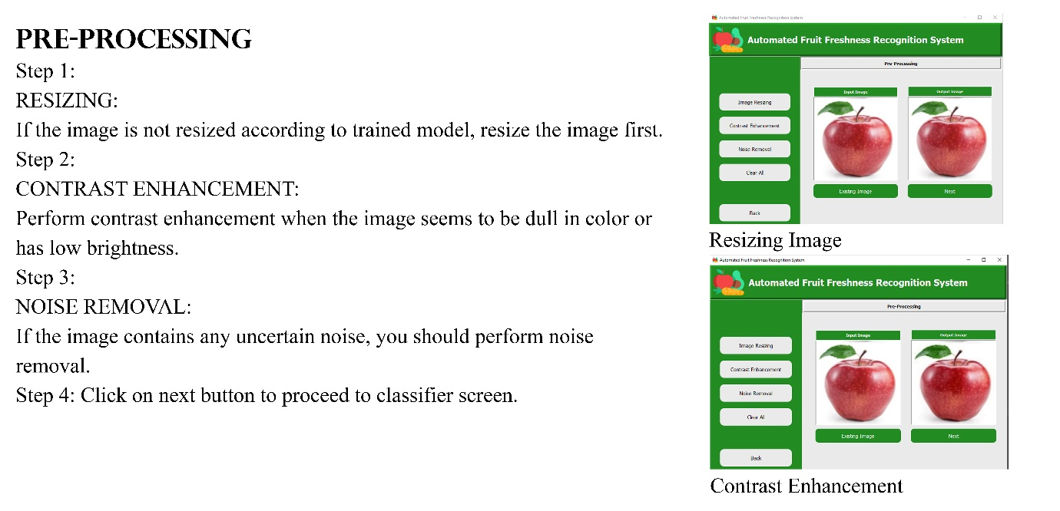

**Figure 5.18 Pre-processing Tutorial**

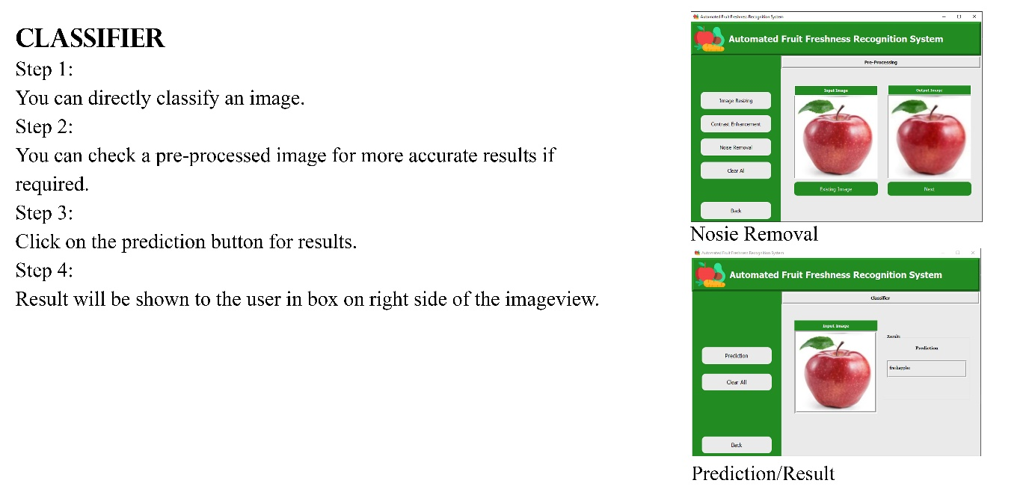

**Figure 5.19 Classifier Tutorial**

# Chapter 6

# TESTING AND EVALUATION

## 6.1 Testing and Evaluation

Evaluation is important stage where we analyze the performance of application by performing different tests to interpret the working of application. In testing phase, we test the functionality of each module of the system. Testing phase also test that our system is according to user’s requirements or not. Evaluation and testing are also essential to debug errors and bugs in system functionality.

## 6.2 Manual Testing

In manual testing there is no use of any automated tool. In this type of testing performance of system is checked by hand. Manual Testing is very helpful to find out visible and hidden defects in a system. The backend coding of algorithms is analyzed line by line to overview the result and examined the functionality of each module of system is checked.

### 6.2.1 System Testing

In system testing the functionality of complete system is evaluated. The interface of a system will be tested in system testing. First input image will be given to the system through interface and then classification is performed result will be checked.

### 6.2.2 Unit Testing

In unit testing we check each unit of our system and check whether the system is according to user requirements or not. In this phase of testing, we also analyze each piece of code to check the flow of application. Python console display warning or error messages too that help us where we are lagging something. Unit Testing can be performed in each unit.

#### 6.2.2.1 Upload Image

Image uploading is done by clicking the button in interface named “**Upload”** it opens the directory that contains the image dataset (.jpg) format. Format other than .jpg is not supported. User can select any image from dataset and that image will display at interface.

#### 6.2.2.2 Preprocessing

All images have .jpg format does not format other than .jpg is supported. All images are saved with their label name. The three operations of preprocessing are performed on image to get a result for further classification of fruit label. These operations are image resizing, contrast enhancement and noise removal these all are applied when the image is uploaded.

#### 6.2.2.3 Dataset

The dataset is divided into two parts.

##### 6.2.2.3.1 Training

Our training data has 6 further directories. We have checked that each of the image has its correct label and saved in correct directory. The training folder is divided into 6 separate folders as Rotten Apples, Unrotten Apples, Rotten Bananas, Unrotten Bananas, Rotten Oranges, Unrotten Oranges. Total of approximately1000 images are taken from each of the folder.

##### 6.2.2.3.2 Testing

Testing images are placed in the test folder. The training folder is divided into 6 separate folders as Rotten Apples, Unrotten Apples, Rotten Bananas, Unrotten Bananas, Rotten Oranges, Unrotten Oranges. Total of 250 images from each directory of tumor class. Now our training folder is reading to load CNN in our model.

##### 6.2.2.4 Classification

For classification, fruit image is preprocessed that are going to be test. The must be free of any noise. We trained CNN model on our dataset. Our pretrained model is saved in .pth extension which we gave to our system and test the image that we gave to the system. The input image is compared with pretrained CNN model. This model detects the fruit label (fresh and rotten) if fruit image is matched then the system displays the output.

### 6.2.3 Functional Testing

In functional testing we test all the functionality of the system also check the functions are working according to the requirements of user or not.

For functional testing, we form the test cases. These testcases are performed to check the functionality of application from user point of view.

**Test Case 1:**

**Table 6.1 Upload Image**

|  |  |  |  |  |
| --- | --- | --- | --- | --- |
| No. | Test case | Attribute and Value | Expected Result | Result |
| 1 | Upload Image | User is required to select .jpg format image from folder. | Image is ready to be displayed. | Image is displayed on interface. |

**Test Case 2:**

**Table 6.2 Without Uploading image**

|  |  |  |  |  |
| --- | --- | --- | --- | --- |
| No. | Test case | Attribute and Value | Expected Result | Result |
| 1 | Without Upload Image | If user click button of any operation. | Error alert to be shown. | Error alert shown instead of image. |

**Test Case 3:**

**Table 6.3 Preprocessing**

|  |  |  |  |  |
| --- | --- | --- | --- | --- |
| No. | Test case | Attribute and Value | Expected Result | Result |
| 1 | Image Resizing | Image must be present in .jpg format in directory. | On button click, resultant image should be resized and displayed. | Resultant image resized and displayed. |
| 2 | Contrast Enhancement | Image must be present in .jpg format in directory. | On button click, resultant image should be contrast enhanced and displayed. | Resultant image enhanced contrast and displayed. |
| 3 | Noise Removal | Image must be present in .jpg format in directory. | On button click, resultant image should be without noise and displayed. | Resultant image is without noise and displayed. |

**Test Case 4:**

**Table 6.4 Classification**

|  |  |  |  |  |
| --- | --- | --- | --- | --- |
| No. | Test case | Attribute and Value | Expected Result | Result |
| 1 | Classification | Compare input image with pretrained load model. | On button click, fruit label should be displayed. | Fruit label is displayed |

### 6.2.4 Integration Testing

**Table 6.5 Integration Testing**

|  |  |  |  |  |
| --- | --- | --- | --- | --- |
| No. | Test case | Attribute and Value | Expected Result | Result |
| 1 | Upload Image | User input image of fruit present in .jpg format from directory. | Resultant image is ready to be displayed. | Resultant image displayed. |
| 2 | Without Upload Image | If user click button of any operation. | Error alert to be shown. | Error alert is displayed instead of image. |
| 3 | Pre-processing | Image must be present in .jpg format in directory. | On button click, resultant image should be displayed. | Resultant image displayed. |
| 4 | Prediction (Classification) | Compare input image with pretrained load model. | Label and other details of image is displayed. | Image label and other details displayed. |

## 6.3 Tools

**Table 6.6 Tools**

| Tool Name | Tool Description | Applied on [list of related tests cases/FR/NFR] | Result |
| --- | --- | --- | --- |
| PyQt Designer | Library (PyQt5) of python | Designing of interface. | GUI (Graphical User Interface). |
| PyCharm | JetBrains PyCharm Community Edition 2019.2.1. | All tests case. | Code is written over it. |
| Anaconda | Anaconda3-2019.10-Windows-x86_64 | All tests case. | It supports libraries. |
| Microsoft Word | WORD 2010 | Used for documentation. | Documentation. |
| Microsoft PowerPoint | PowerPoint 2010 | Used for presentation. | Presentation slides. |

# Chapter 7

# CONCLUSION AND FUTURE WORK

## 7.1 Conclusion

After the study and implementation of deep learning in the field of fruit freshness it is concluded that using Convolutional Neural Network (CNN) provides very competitive results. For the implementation first, we have taken images of fruits from Kaggle. Then the model of CNN is trained for the test of the 2 different classes of 3 fruit types. After the model was trained on the given images the network was able to classify the fruit as rotten and fresh into different classes. For this current work, 94% accuracy was achieved with CNN architecture. This high percentage is due to the use of CNN as our classifier and epochs. We have tried to use more images than the previous images to achieve better performance. So, we can say that deep learning is one of the best architectures in the field of fruit recognition and classification of fruit freshness.

Not a lot of work has been done for the development of this application. There is a lot of work to be done in this field and can be incorporated into advanced platforms in the future. This is the beginning of research in this field for fruits and it was found that Convolution Neural Network would be providing promising results in this field. In this computer system, we don’t even require segmentation and feature extraction for the classification, CNN does it all. As mentioned above we have got an overall 94% accuracy of the network. The six types of classes Rotten Apples, Fresh Apples, Rotten Oranges, Fresh Apples, Rotten Bananas, and Fresh Bananas were used for prediction. We achieved the highest 96.99 % accuracy for the fresh oranges, 94.87 for rotten oranges, 95.43% for rotten apples, 95.18% for fresh apples, 95.27% for fresh bananas, and 89.69% for rotten bananas. All this was performed using machine learning techniques as mentioned earlier.

## 7.2 Future Work

In near future, this Fruit freshness system would help the large markets to check the fruit freshness avoiding the traditional method of examination of the fruits that is done by the humans through which many of the fruits are ignored directly. This all will be done using CNN algorithm used in our system. As with time fruit decays and this will save time and with its simplicity it is easy to use at marketplaces or at other large scale production companies i.e., Juice Companies, Ice cream Companies etc. In future we will aim to extend the proposed model by including additional types of fruits other than apple, orange and banana. Since it is based on machine learning techniques, so a real time camera can be used to classify the fruit freshness.

# Chapter 8

# REFERENCES

## References

1. Sa, I., Ge, Z., Dayoub, F., Upcroft, B., Perez, T., & McCool, C. (2016). DeepFruits: A Fruit Detection System Using Deep Neural Networks. Sensors, 16(8), 1222. https://doi.org/10.3390/s16081222
2. Song, Y., Glasbey, C. A., Horgan, G. W., Polder, G., Dieleman, J. A., & van der Heijden, G. W. A. M. (2014). Automatic fruit recognition and counting from multiple images. Biosystems Engineering, 118, 203–215. https://doi.org/10.1016/j.biosystemseng.2013.12.008
3. Bargoti, S., & Underwood, J. (2017). Deep fruit detection in orchards. 2017 IEEE International Conference on Robotics and Automation (ICRA). https://doi.org/10.1109/icra.2017.7989417
4. h Fu, Y., 2020. Fruit Freshness Grading Using Deep Learning. [ebook] School of Engineering, Computer and Mathematical Sciences. Available at: <https://openrepository.aut.ac.nz/bitstream/handle/10292/13353/Fruit_Fu_24May2020_wyan.pdf> [Accessed 7 October 2020].
5. Kalluri, S. R. (2018, August 24). Fruits fresh and rotten for classification. Retrieved October 7, 2020, from https://www.kaggle.com/sriramr/fruits-fresh-and-rotten-for-classification
6. Cs.toronto.edu. 2021. *convnet*. [online] Available at: https://www.cs.toronto.edu/~lczhang/aps360_20191/lec/w03/convnet.htmls.
7. PyTorch, B., 2021. *Convolutional Neural Network Pytorch | CNN Using Pytorch*. [online] Analytics Vidhya. Available at: <https://www.analyticsvidhya.com/blog/2019/10/building-image-classification-models-cnn-pytorch/>.
8. Pytorch.org. 2021. *torch — PyTorch 1.8.1 documentation*. [online] Available at: <https://pytorch.org/docs/stable/torch.html#torch.unsqueeze> .
9. Pytorch.org. 2021. *Training a Classifier — PyTorch Tutorials 1.8.1+cu102 documentation*. [online] Available at: <https://pytorch.org/tutorials/beginner/blitz/cifar10_tutorial.html>.